

**UNITED STATES INTERNATIONAL UNIVERSITY AFRICA  
NAIROBI, KENYA  
DST4010 A: DISTRIBUTED SYSTEMS**

**UNIVERSITY MID-TERM EXAMINATIONS**

**FALL SEMESTER 2021**

**INSTRUCTOR: LINUS ALOO**

**DATE: 18TH OCTOBER, 2021 TIME: 1HR 45MINS**

**INSTRUCTIONS**

1. This paper consists of 4 Questions.
2. Answer **QUESTION ONE** and any **OTHER TWO** Questions.
3. Diagrams should be drawn neatly.

**NAME………………………………………………….ADM. NO………………….**

**QUESTION ONE-COMPULSORY [20MARKS]**

a) A distributed system is built based on cellular mobile communication technology for use in an IOT application. The distributed system has four smart phones-1, 2, 3 & 4, which are geographically apart, one Central Office Server, two LTE base stations (Cell Towers-1 & 2).

(i) Define the following terms with respect to the given distributed system case. **[3marks]**

1. Access and Location transparency
2. Mobility transparency
3. Quality of Service (QoS)

**ANS:**

1. **The distributed systems should work in a way that the user does not know where the system is located or how it works**
2. **Mobility transparency is where data and resources in use can be transferred across systems without the user being bothered with the details**
3. **Quality of service involves the efficiency, speed, security of the systems to the users of the system**

(ii) Using Packet Tracer Software, design the distributed communication system and show clearly the transmission of messages between the smart phone devices 1 & 3 on one hand and 2 and 4 on the other hand in the distributed system. Explain clearly the design decisions made as well as the technical issues to improve on the system performance. **[10marks]**

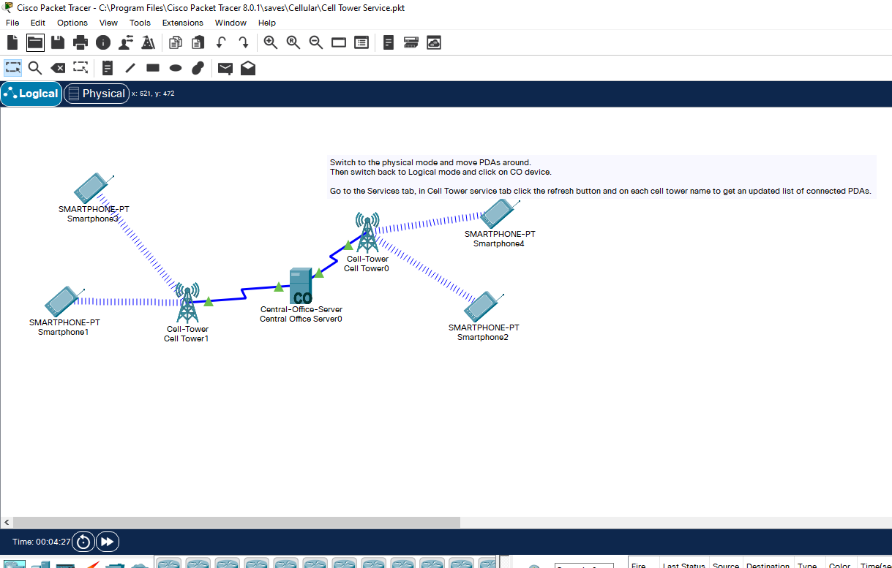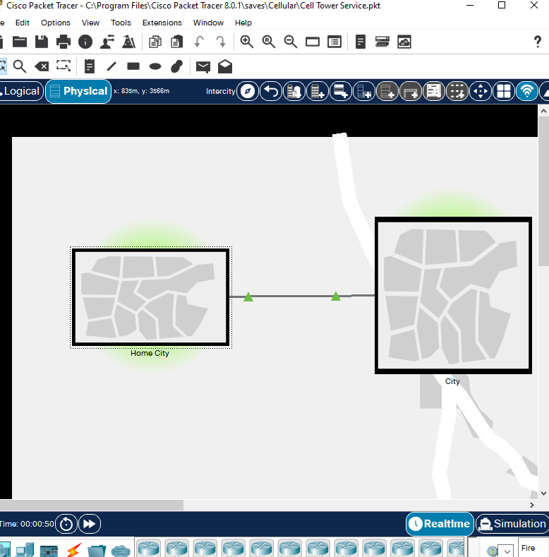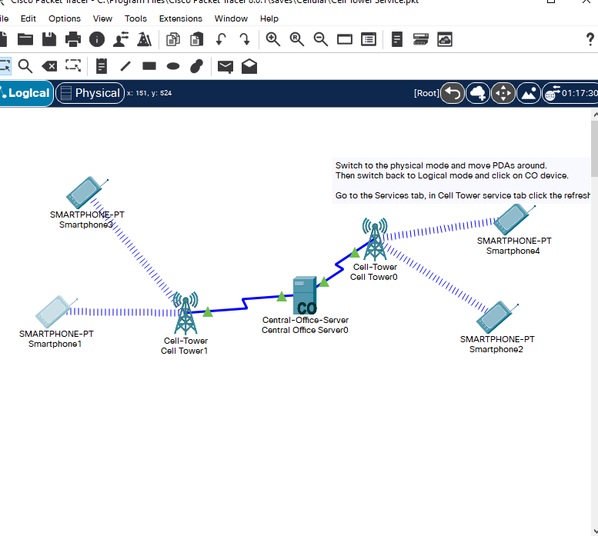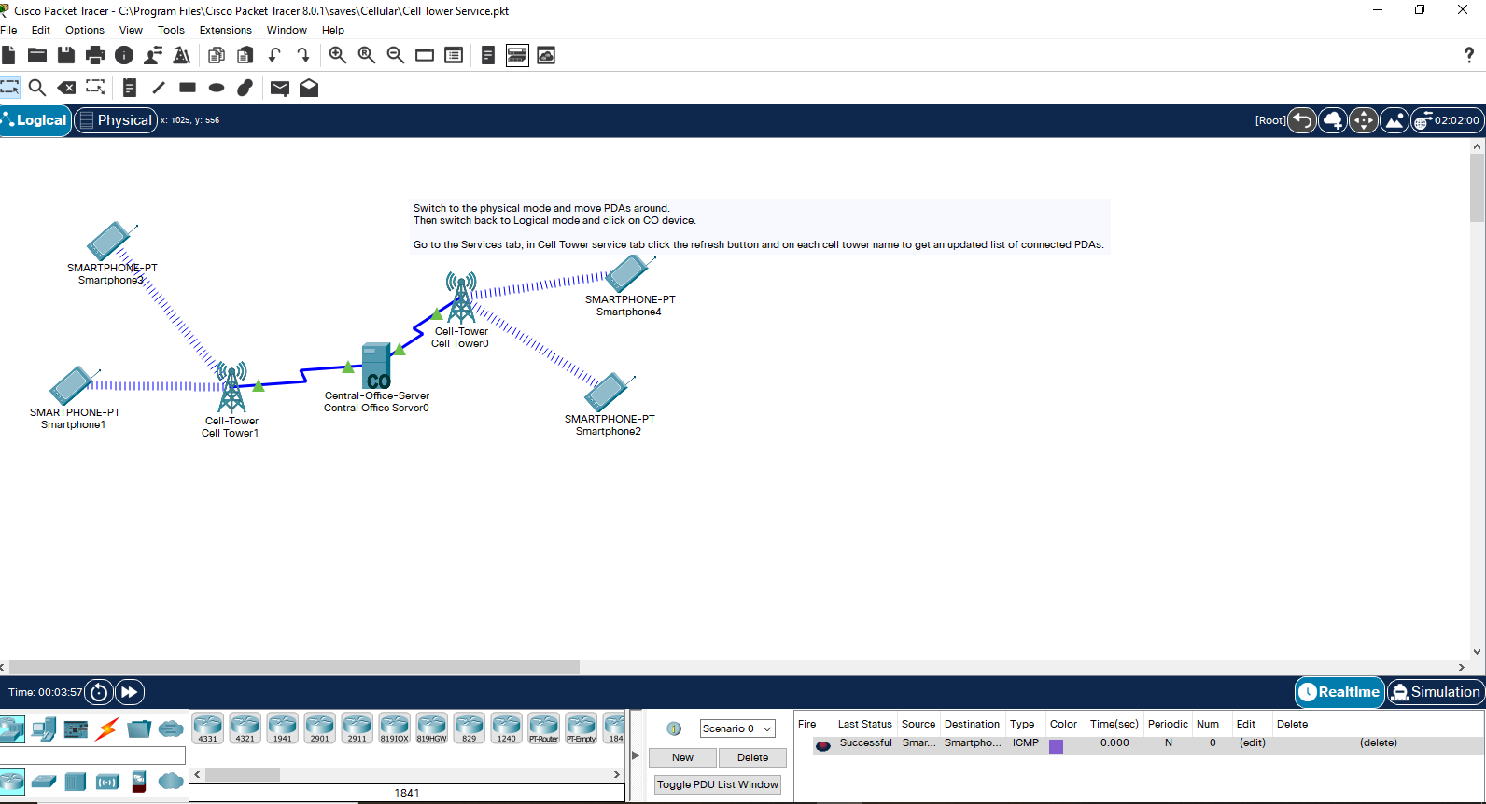

Smartphone 1 and 3 are connected to cellphone tower 1 and communicate to the Central office server 0 which then send packets to cell tower 0 from which smartphones 2 and 4 can access the packets

b) Soccer score updates are to be accessed from servers distributed across the internet. The current page with the soccer score updates should be updated in between requests. Show how a user will be able to access updated scores. **[3marks]**

**ANS:**

**The user requests the data from the online servers by sending http requests to the web servers… the client then accesses records that are updated by employees on the pitch who update the pages regularly…**

**The clients can also use SOAP where the registry is updated regularly as the client constantly requests for updates**

c) What is the main relationship between Remote method invocation (RMI) and Remote procedure call (RPC) as used in distributed systems? **[1mark]**

**ANS:**

**RPC is used mostly for object oriented languages like java while RMI is used for procedural programming languages like C as in the name**

d) Synchronization is important in communication performance and data consistency with respect to distributed systems. Identify and briefly highlight key features of the three places for synchronization in a distributed communication architecture. **[3marks]**

**ANS:**

**Data in the osi layer is separated into packets and sent from the client to the receiver where the packets are put together … synchronization is important in the physical layer in this case**

**QUESTION TWO [15MARKS]**

a) One of the methods that enable communication in a distributed system environment is by Tuple spaces (also known as generative communication).

1. Identify three simple operations that can be used to manage tuples in a typical distributed systems environment. **[3marks]**

**ANS:**

**(out) which is used for writing data into the tuple spaces**

**(in) which is used for withdrawing data from the tuples**

**(rd) which is used for reading the data in the tuple spaces**

1. Given three tuples: t1 (Tom), t2 (Mary) and t3 (Kai), all within Linda TupleSpace, write a simple program in your preferred language to illustrate access to a blog name *linda.universe* distributed over the internet. Create your own messages or strings for each tuple. **[8marks]**

**ANS:**

Pseudocode…

T1(out) linda.universe // Tom adds data onto the blog

T2(in) linda.universe // Mary edits some of the data in the blog

T3(rd) linda.universe // Kai reads the blog

b) By considering a peer-to-peer distributed system, identify and explain the two main characteristic features of distributed systems. **[4marks]**

**ANS:**

**All the components work coherently together like one system…p2p systems involve devices that are sharing separate pieces of data of the same data to other devices but it appears to the user like its only one place for example torrents**

**The component are autonomous which means each component is able to function by itself…for p2p systems each device functions by itself and can continue working seamlessly when others fail**

**QUESTION THREE [15MARKS]**

a) Give practical examples of distributed systems under the following categories:  **[3marks]**

1. Finance and commerce
2. Health care
3. Education

**ANS:**

b) i) Draw a typical diagram to show how interprocess communication is supported through sockets and ports in a distributed system environment and explain how it works. **[4marks]**

**ANS:**

(ii) Write a typical program in C++ or Java that a client can use to send a message to the server and get a reply in a distributed system. Using NetBeans Software or equivalence, execute the program and present a screen short of the simulated program. [**8marks]**

**ANS:**

**QUESTION FOUR [15MARKS]**

a) In a typical financial trading distributed system, a client wants to trade in HP shares (HPQ) and Microsoft shares (MSFT). Write a typical program that will handle events in such a distributed system. **[3marks]**

**ANS:**

**It works based on selling when share price is high and buying when shares are low**

**So assuming hp shares sell at around 15 units and Microsoft shares sell at around 20 units**

**if(HPQ<=12.5)**

**Buy HPQ;**

**else if(hp>=22.5)**

**sell HPQ;**

**if (MSFT<=18)**

**buy MSFT;**

**else if(MSFT>=22)**

**sell MSFT;**

b). An Air Ticket booking company uses two Web services to generate travel tickets based on SOAP architecture. Draw a block diagram of the Air ticket online booking system based SOAP Web service and with specific examples, explain how the ticket is actually raised. **[5marks]**

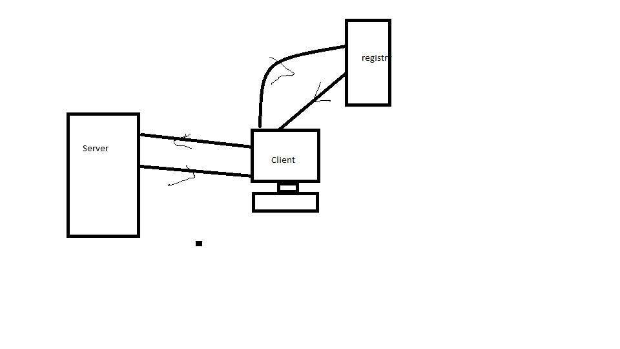

**The system works in a way that the user/client generates a ticket based on information on the registry of available seats and sends information of seats booked to the registry this is done via communication with the server to update and alter the records**

c) Give two challenges of distributed systems and how they can be mitigated. **[2marks]**

**ANS:**

**Scalability… with rapidly growing distributed systems, the systems created need to be able to be up scaled to avoid having to create a whole new system to support new clients and servers**

**They should also be able to be downscaled in case some resources are not being used**

**Security.. with most of the systems in use not being in one location… security is one of the leading problems of distributed systems… this can be mitigated by training/hiring personnel or acquiring private servers and even use of vpns when using said systems**

d) Draw block diagram of a typical client-server distributed system with two clients and two Web servers through a Proxy server and explain how a user can access distributed resources.

**[5marks]**

**ANS:**

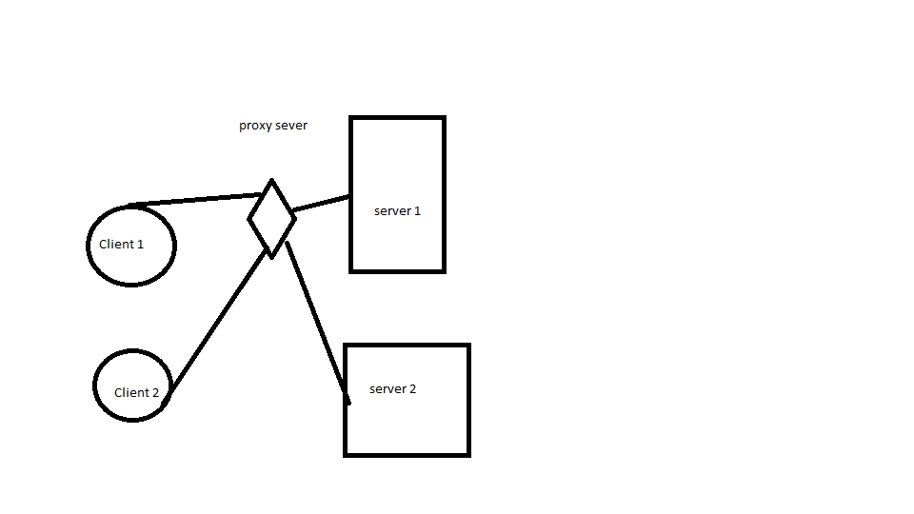

**The clients connect to the servers via the proxy… an example would be like a PlayStation console connecting to the internet by connecting to a laptops hotspot hence the name by proxy**

**END OF EXAMS**